Hierarchies (ˈhaɪərɑ:kɪ)

Содержание

Parent Child иерархия Эмитент - Районы

Parent Child иерархия Эмитент – Комплекс АЗС

The Parent Child hierarchy in HANA
https://archive.sap.com/documents/docs/DOC-65213
Импорт таблицы из локального файла в HANA.
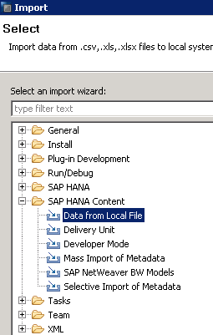
Создание Parent-Child иерархии на основе таблицы.

Проверить, сгенерировалась ли иерархия, можно по выборке SELECT из соответствующей таблицы
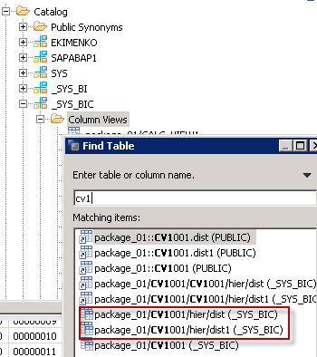

From А_Кузнецов
Напрямую импортировать bw иерархию в CV к сожалению никак насколько я знаю...
В HANA свои иерархии, в HANA свои.
Есть описание подхода когда parent-child иерархию BW переводят в иерархию по уровням –
https://blogs.sap.com/2015/12/16/bw-hiearchy-in-hana-modelling/
и там же Use Case 2: Parent / Child Based Hierarchy – как использовать BWшную.
Но это предполагает, что затем отчетность строится уже не на композите а напрямую на CV.

Иерархия сгенерировалась и появилась –

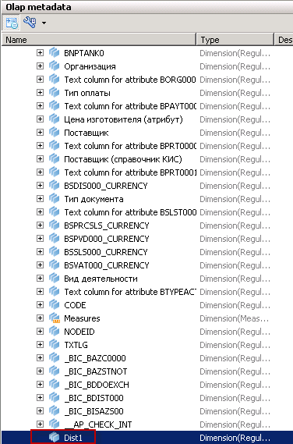

Но, при попытке ее открыть –
com.sap.db.jdbc.exceptions.JDBCDriverException: SAP DBTech JDBC: [256]: sql processing error: Hierarchy create error for "_SYS_BIC"."package_01/CV_01/dist1/hier/dist1" error: SQL: insufficient privilege

Я так понимаю, что это определяется свойствами CV, а вот какими из ?
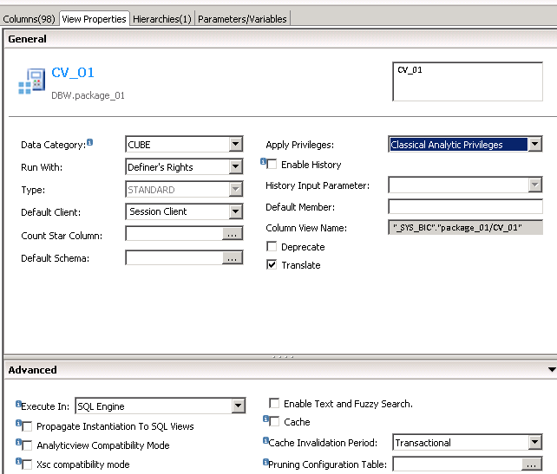
Пробовал менять 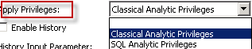 - не помогает.

P.S.
Это СV CV_01 в QBW

Attribure View
package_01::ATV_DIST DBW (EKIMENKO)
Иерархия 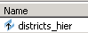

Таблица иерархии –

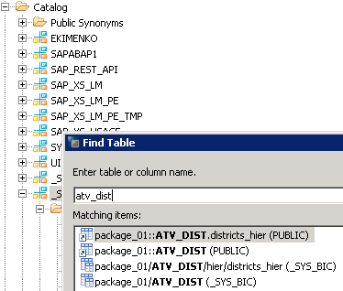

For View - _SYS_BIC.package_01/ATV_DIST/hier/districts_hier

SELECT * FROM “PUBLIC”.”package_01::ATV_DIST.districts_hier”

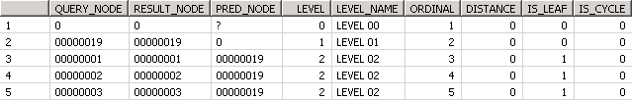

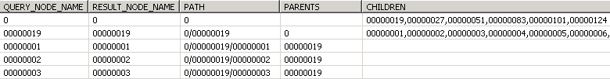

SELECT top 1000 * FROM “_SYS_BIC”.”package_01/ATV_DIST/hier/districts_hier”

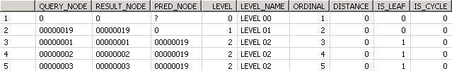

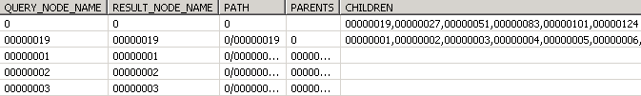

SAP HANA Calculation View Classical Analytic Privileges SQL Analytic Privileges

Use Case 1 - Level Based Hierarchy

Flattening is based on tracing the parent of every node starting from leaf node.
Ex GL Hierarchy. It is an unbalanced Hierarchy.

Steps –
- Import/Enable BW Hierarchy Table into HANA so it can be used in Models –
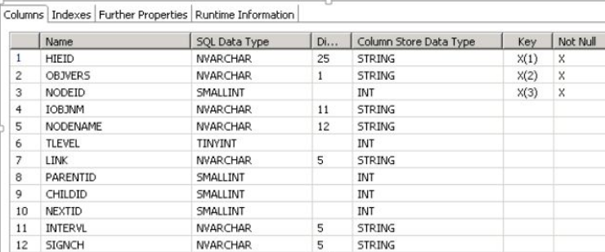

Data Preview –

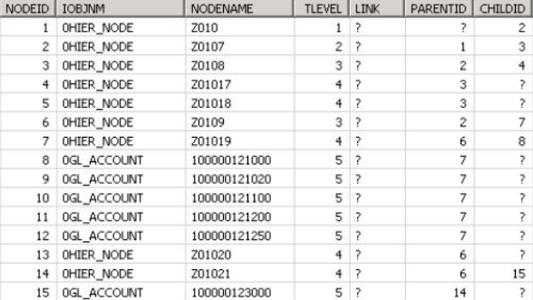

- Scripted Calculated view needs to be created to flatten the hierarchy.

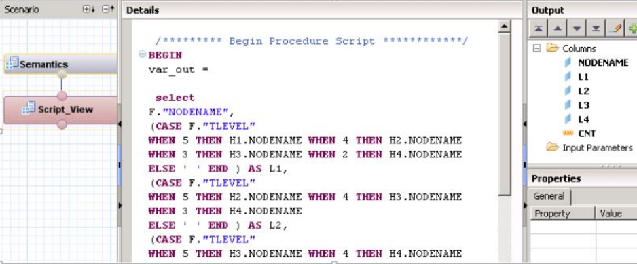

Below is the code snippet to flatten a 4 Level Hierarchy. You can expand the code to have more levels if required. This is just an example -

select
F.“NODENAME”,
(CASE F.“TLEVEL”
WHEN 5 THEN H1.NODENAME
WHEN 4 THEN H2.NODENAME
WHEN 3 THEN H3.NODENAME
WHEN 2 THEN H4.NODENAME
ELSE ‘ ‘ END ) AS L1,
(CASE F.“TLEVEL”
WHEN 5 THEN H2.NODENAME
WHEN 4 THEN H3.NODENAME
WHEN 3 THEN H4.NODENAME
ELSE ‘ ‘ END ) AS L2,
(CASE F.“TLEVEL”
WHEN 5 THEN H3.NODENAME
WHEN 4 THEN H4.NODENAME
ELSE ‘ ‘ END ) AS L3,
(CASE F.“TLEVEL”
WHEN 5 THEN H4.NODENAME
ELSE ‘ ‘ END ) AS L4
FROM “BHO_POC”.“GL_HIER1” F
LEFT OUTER JOIN “BHO_POC”.“GL_HIER1” H4 ON H4.“NODEID” = F.“PARENTID”
LEFT OUTER JOIN “BHO_POC”.“GL_HIER1” H3 ON H3.“NODEID” = H4.“PARENTID”
LEFT OUTER JOIN “BHO_POC”.“GL_HIER1” H2 ON H2.“NODEID” = H3.“PARENTID”
LEFT OUTER JOIN “BHO_POC”.“GL_HIER1” H1 ON H1.“NODEID” = H2.“PARENTID”
where F.“IOBJNM” = ‘0GL_ACCOUNT’
and F.“OBJVERS” = ‘A’;

Data Preview from the Calculated View – This is an unbalanced hierarchy, however the same code will work in case of a balanced hierarchy as well -

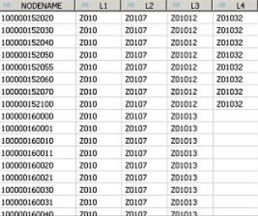

Similar result can be achieved using a HANA Function, however the performance may not be as good as above as a select is done for each row to get the parents vs a join as in above sql. The SQL in calculation view becomes much simpler with using FUNCTION.

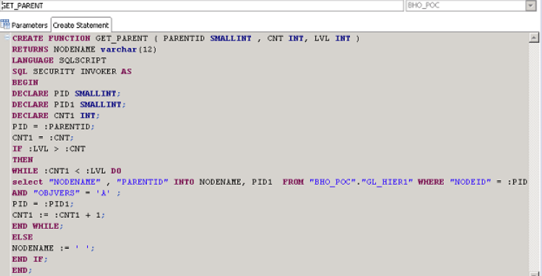

SQL to create Function

CREATE FUNCTION GET_PARENT (PARENTID SMALLINT, CNT INT, LVL INT )
RETURNS NODENAME varchar(12)
LANGUAGE SQLSCRIPT
SQL SECURITY INVOKER AS
BEGIN
DECLARE PID SMALLINT;
DECLARE PID1 SMALLINT;
DECLARE CNT1 INT;
PID = :PARENTID;
CNT1 = :CNT;
IF :LVL > :CNT THEN
WHILE :CNT1 < :LVLDO
select “NODENAME” , “PARENTID” INTO NODENAME,
PID1 FROM “BHO_POC”.“GL_HIER1” WHERE “NODEID” = :PID AND “OBJVERS” = ‘A’ ;
PID = :PID1;
CNT1 := :CNT1 + 1;
END WHILE;
ELSE NODENAME := ‘ ‘;
END IF;
END;

Calculation View to generate levels for all leaf value. You can see that adding level becomes much easier when compared to not using FUNCTION –

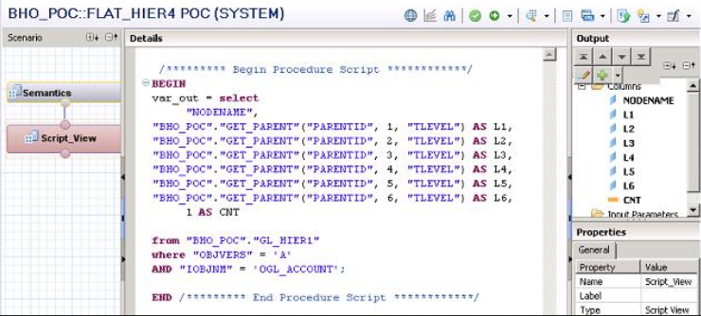

Example – For following –

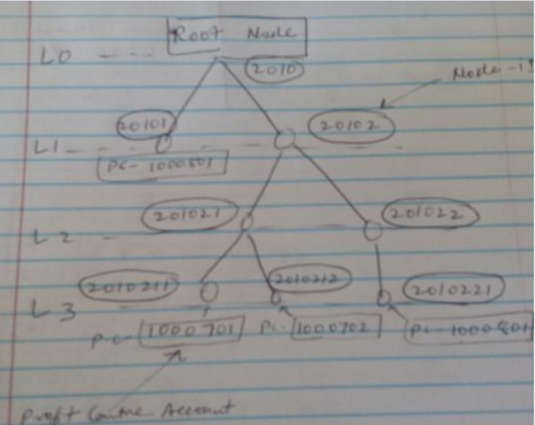

Out of following picture will be –
1000701(Leaf Value) –> 2010211 (L4) -> 201021 (L3) -> 20102 (L2) -> 2010(L1)
1000702(Leaf Value) –> 2010212 (L4) -> 201021 (L3) -> 20102 (L2) -> 2010(L1)
1000501(Leaf Value) –> -> (L4) –> — (L3) -> 20101 (L2) –> 2010 (L1)
Flattened Table from Calculation View –

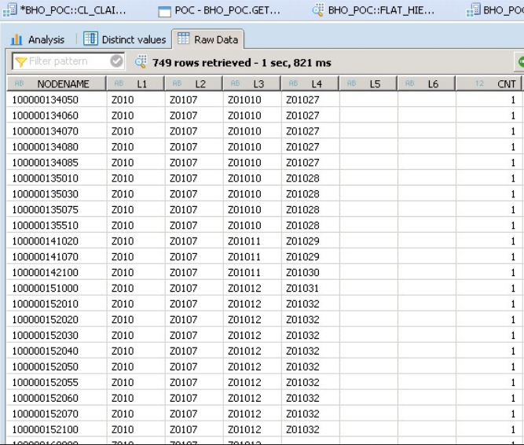

We can create level based on hierarchy in HANA based on column L1, L2, L3 etc. The above calculation view can be joined to transactional data and then the hierarchy can be defined on the semantic layer of the final reporting view.

Issues with Flattened tables –
When we expand hierarchy in Analysis for Office OR Design studio tools – Blank Level are displayed as spaces. It need additional tackling (отбор) in front end-tool.

Use Case 2 - Parent / Child Based Hierarchy

Well, there is no direct way to do it, but the following workaround will help you extract and replicate the hierarchy in HANA from BW. You can use the BW Hierarchy table and use the NODEID and PARENTID fields to define a Parent Child relationship in the Hierarchy Tab in the Semantic layer of the final reporting view.
I will take the example of HR Hierarchy. It is an organizational hierarchy based on Employee i.e. has each employee and its Manager has an entry
in the Hierarchy. The structure of BW Hierarchy table is same as in first use case, however the data is different –

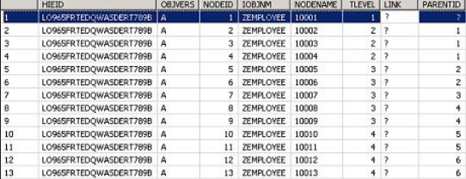

Define an Attribute View with three fields - NODEID, PARENTID and NODENAME. Or you can add the hierarchy table to the Master Data Table for the object in the Attribute view of the object, in this case ZEMPLOYEE and then add the three fields –

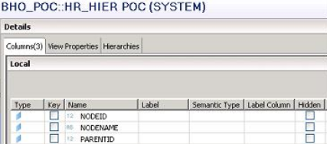

Use this Attribute view in a reporting Analytic View or Calculation View ( Join on ZEMPLOYEE) and then define the Hierarchy in the Semantic Layer as Below –

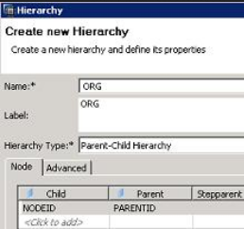

Once the Hierarchy is defined in either use cases they can be used in Frontend Tools for reporting.

Don’t work parent child hierarchy in sap hana calculation view

- https://blogs.sap.com/2017/08/18/working-with-sap-hana-parent-child-hierarchies/

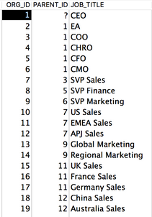

Adding the Label Column allows us to display the JOB_TITLE and not just the ORG_ID –

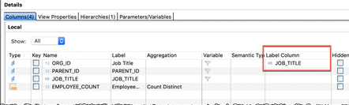

Analytic Privileges
Alternatively, if Analysis for Office or SAP Analytics Cloud are not available then one workaround is to view the hierarchy within the Analytic Privileges.
To do this, we need to Enable Hierarchies for SQL Access in the Calc View properties - this property is exposed if we have a Star Join within Calc View –

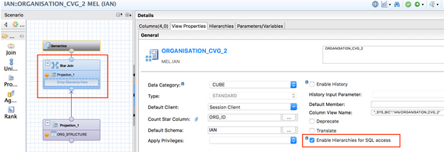

Within the Analytic Privileges dialogue, we can find our hierarchy after first selecting the child attribute, ORG_ID –

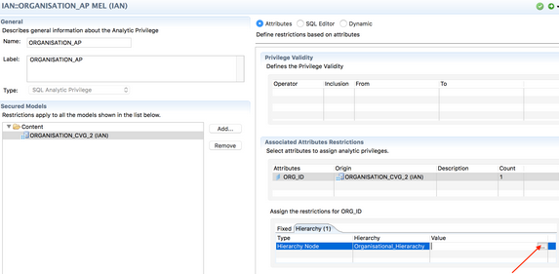

We can then test and browse our hierarchy, here it shows both the ID (Value) and the Label (Description) –

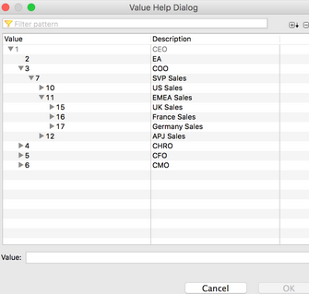

So far so good, now joining this hierarchy dimension to a fact table should be straight forward, and it is, provided you use the correct join – an outer join –

create column table EXPENSES (ORG_ID int, EXPENSE_AMOUNT int);
insert into EXPENSES values (1,430);
insert into EXPENSES values (2,120);
insert into EXPENSES values (3,100);
insert into EXPENSES values (4,250);
insert into EXPENSES values (5,530);
insert into EXPENSES values (6,180);
insert into EXPENSES values (8,450);
insert into EXPENSES values (9,250);
insert into EXPENSES values (10,160);
insert into EXPENSES values (12,350);
insert into EXPENSES values (13,130);
insert into EXPENSES values (14,300);
insert into EXPENSES values (15,140);
insert into EXPENSES values (16,550);
insert into EXPENSES values (18,170);
insert into EXPENSES values (19,150);

A common scenario is that not all the organisation entities will appear in the fact table, but they are still part of the hierarchy. We want to ensure that our reporting is accurate, and not lose and information. To achieve this we should use a left outer join on the dimension table –

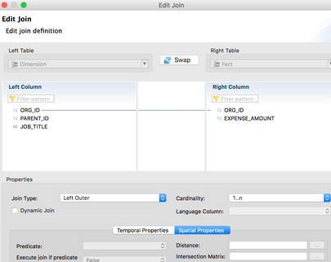

Note
The hierarchies belonging to an attribute view are available in an analytic view that reuses the attribute view, in read-only mode. However, the hierarchies belonging to an attribute view are not available in a calculation view that reuses the attribute view.

Select the Add Root Node checkbox if required.
Note
If a hierarchy does not have a root node but needs one for reporting use case, set the option to true - this will create a root node.

Select nodename,
Case when parented = 0 then null else parented end as parented,
Childid from "/BIC/HBDIST000"

bl-sap-dbw.it.beloil.by:30015

QAS
URL http://sapbo-qas.it.beloil.by/BOE/BI
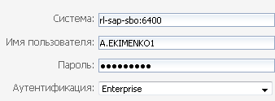
Логин a.ekimenko1
Пароль Qa1234567

Parent Child иерархия Эмитент - Районы

Содержание

Спасибо автору https://blogs.sap.com/2017/01/26/advance-hierarchy-modeling-with-sap-hana/

- Создаем Scripted CV типа DIMENSION (Scripted CV типа DIMENSION создать нельзя!)

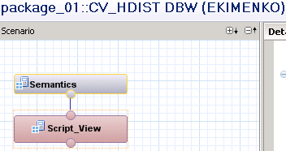

BEGIN
var_out = select
h0.nodename as NODENAME,
(case h0.tlevel
when 2 then h1.nodename else '' end
) as PARENTID,
t_dist.txtlg as TXTLG,
1 as VIRT -- измерение
from "SAPABAP1"."/BIC/HBDIST000" as h0
left outer join "SAPABAP1"."/BIC/HBDIST000" as h1
on h1.nodeid = h0.parentid
left outer join "SAPABAP1"."/BIC/TBDIST000" as t_dist
on t_dist."/BIC/BDIST000" = h0.nodename;
END

- Создаем Parent Child иерархию

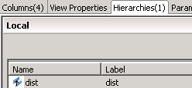

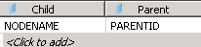

- Создаем переменную иерархии

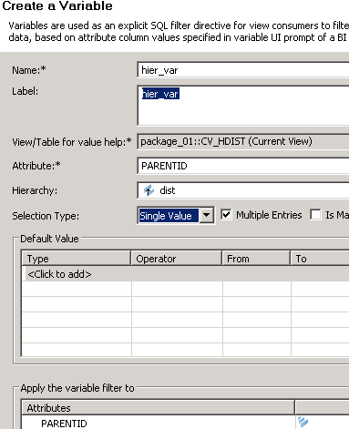

- Задаем текст узлов

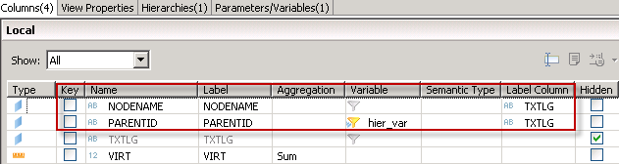

- Активируем и проверяем

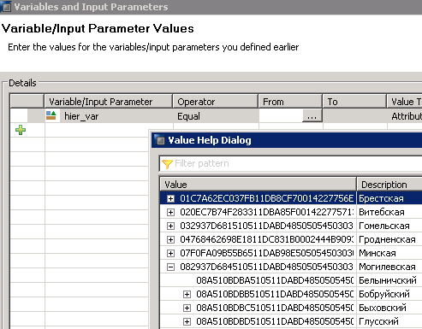

Parent Child иерархия Эмитент – Комплекс АЗС

Содержание

- Создаем Table Function "EKIMENKO"."RetailAzs::tf_azs_hier1"

FUNCTION "EKIMENKO"."RetailAzs::tf_azs_hier" ( )
RETURNS table (
"NODENAME" varchar(10),
"PARENTID" varchar(10),
"TXTLG_azc" varchar(200),
"TXTLG_emit" varchar(30))
)
LANGUAGE SQLSCRIPT
SQL SECURITY INVOKER
default schema SAPABAP1
AS
BEGIN
hier_azs =
select azc."/BIC/BAZC0000" as "NODENAME",
azc."/BIC/BEMIT000" as "PARENTID",
t_azc.txtlg as "TXTLG_azc",
t_emit.txtlg as "TXTLG_emit"
from "SAPABAP1"."/BIC/PBAZC0000" as azc
left outer join "SAPABAP1"."/BIC/TBAZC0000" as t_azc
on t_azc."/BIC/BAZC0000" = azc."/BIC/BAZC0000"
left outer join "SAPABAP1"."/BIC/TBEMIT000" as t_emit
on t_emit."/BIC/BEMIT000" = azc."/BIC/BEMIT000";

return
select "NODENAME", "PARENTID", "TXTLG_azc", "TXTLG_emit" from :hier_azs;
END;

- Активируем и проверяем работоспособность

select * from "EKIMENKO"."RetailAzs::tf_azs_hier1" ( )

- На базе TF создаем CV типа DIMENSION - RetailAzs::CV_AZS_HIER

- Определяем в нем Level Hierachy - hazs

- Добавляем этот CV к CV типа CUBE with star join - RetailAzs::CV_RC_AZS_H

